**Analytics visual structure and visualization:**

1. I imported the database and used the customers, assessments , customer_race and races table to build by analytical database structure
2. I build the analytical database structure in mysql itself. Final Db structure and data has been dumped and uploaded to the Git hub as **LPS_metrics.sql**
3. I didn’t use tool for creating analytical DB. Since the data set is small, I created them and loaded them using simple sql queries itself.

The analytical DB has a metrics table – **lps_metrics.fact_score** and

Four dimension table as appears in the below screen shot

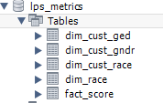

I did a snow flake schema for this particular report because customer has multiple race . If I directly added Race_ID to the fact table then I would have ended in duplicates. So I went with snow flake schema design which appeared more logical to me.

1. I have used tableau for creating the reports in regards to Gender, race and GED. The tableau report has been uploaded to the Github folder as **packagelps.twbx.** It’s a packaged workbook that has data in it as well. You would need tableau desktop to open this work book.

It can be downloaded from below website and can be used as trial version if you don’t have a license

<https://www.tableau.com/products/desktop/download>

1. Below is the view of how final report will look like:

**NOTE: I can add more visualization, calculated field and drill down report. Based on the time constraint I restricted myself to create below view with limited information**

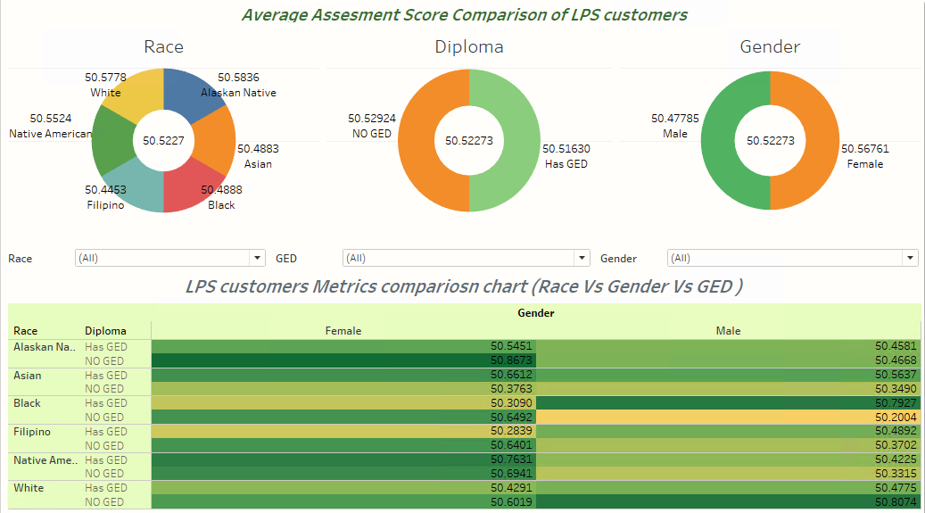

1. First three doughnut charts represents the average score of customers in all three different segments like Race, Diploma and Gender.
2. The below chart is more detailed and can be filtered upon Race, GED and Gender. Hovering over a particular dimension will provide more information about that segment like

* Customer count of the segment
* Median Score of the segment
* Average score of the segment